**DATA LITERACY WITH TABLEAU**

**Exploring world’s Top Youtube Channels**

**A**

**Project report**

**Submitted to**

**Alagappa University, Karaikudi**

**Through**



**under**



**A.JOSEPHINE(TEAM LEADER),**

**K.PRIYANKA,**

**S.NAYAGA PRIYADHARSHINI,**

**A.GAYATHIRI.**

**(3RD PHYSICS)**

**UG DEPARTMENT OF PHYSICS**

**IDHAYA COLLEGE FOR WOMEN, SARUGANI, SIVAGANGANI-DT.**

**1. INTRODUCTION**

1.1 Overview

You Tube is an online video sharing and social media platform headquartered in San Bruno, California, United States. Accessible worldwide,it was launched on February 14,2005, by Steve Chen, Chand Hurley, and Jawed Karim . It is owned by Google and is the second most visited website in the world, after google search.

**1.2 Purpose**

You Tube is a free video sharing website that makes it easy to watch online videos .You can even create and upload your own videos to share with others .Originally created in 2005,Youtube is now one of the most popular sites on the web,with visitors watching around 6 billions hours of every month.Youtube has had unprecedented social impact,influencing popular culture,internet trends,and creating multimillionaire celebrites.

**Project Architecture**



**2. Problem Definition & Design Thinking**

The team members ideas are grouped by Empathy Map and Ideation & Brainstorming Map using app. mural.co

Here we done the following

➢ Defining the problem

➢ Problem understanding

➢ Specification of the business problem .

**Empathy Map:**

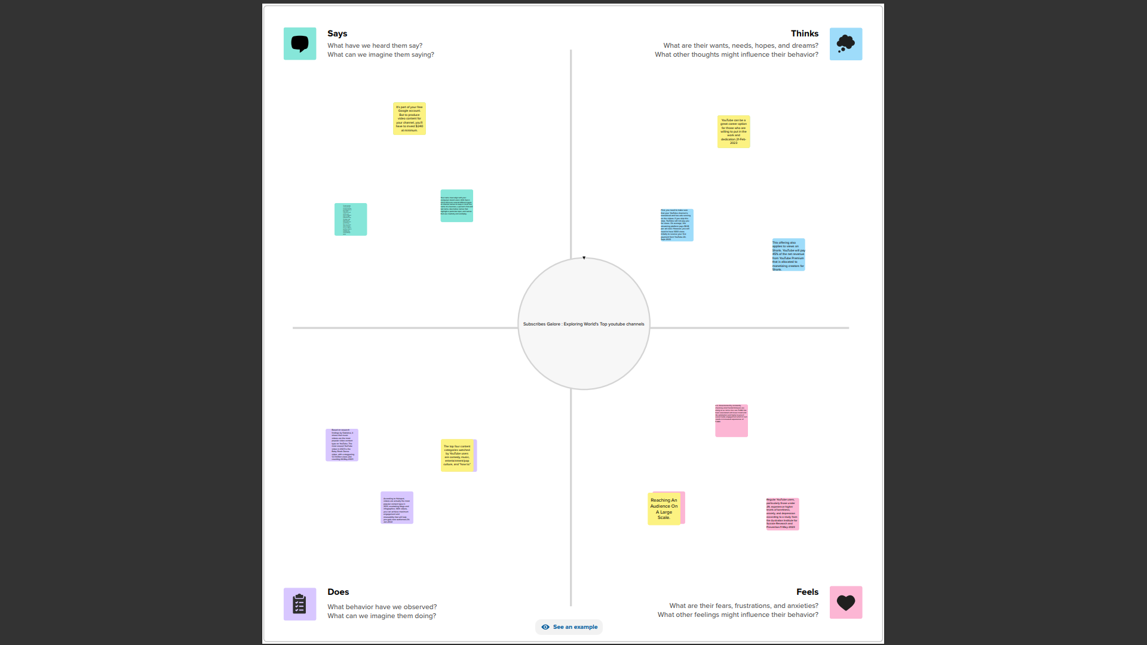

**Ideation & Brainstorming Map:**

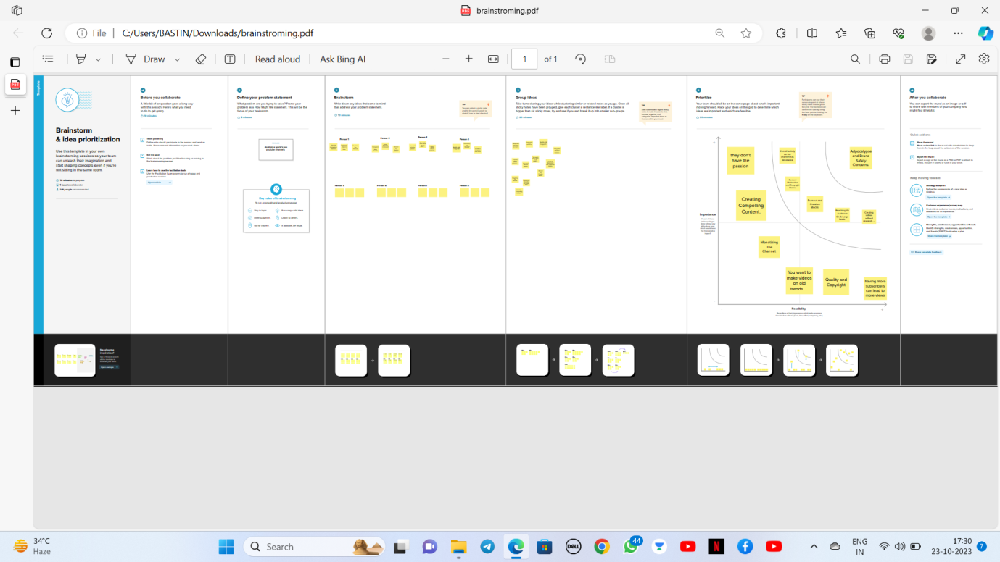

**3. RESULT**

One of the main advantages of Tableau is its easy to use. We

don't need to have any coding or programming skills to create stunning and informative dashboards, charts, maps, and stories with Tableau. You can simply drag and drop data sources, fields, filters, and visual elements to customize your views and analysis. Once you have created views on different sheets in Tableau, you can pull them into a dashboard.

**These are screenshots of our project work**

1. **Screenshots of Sheets**

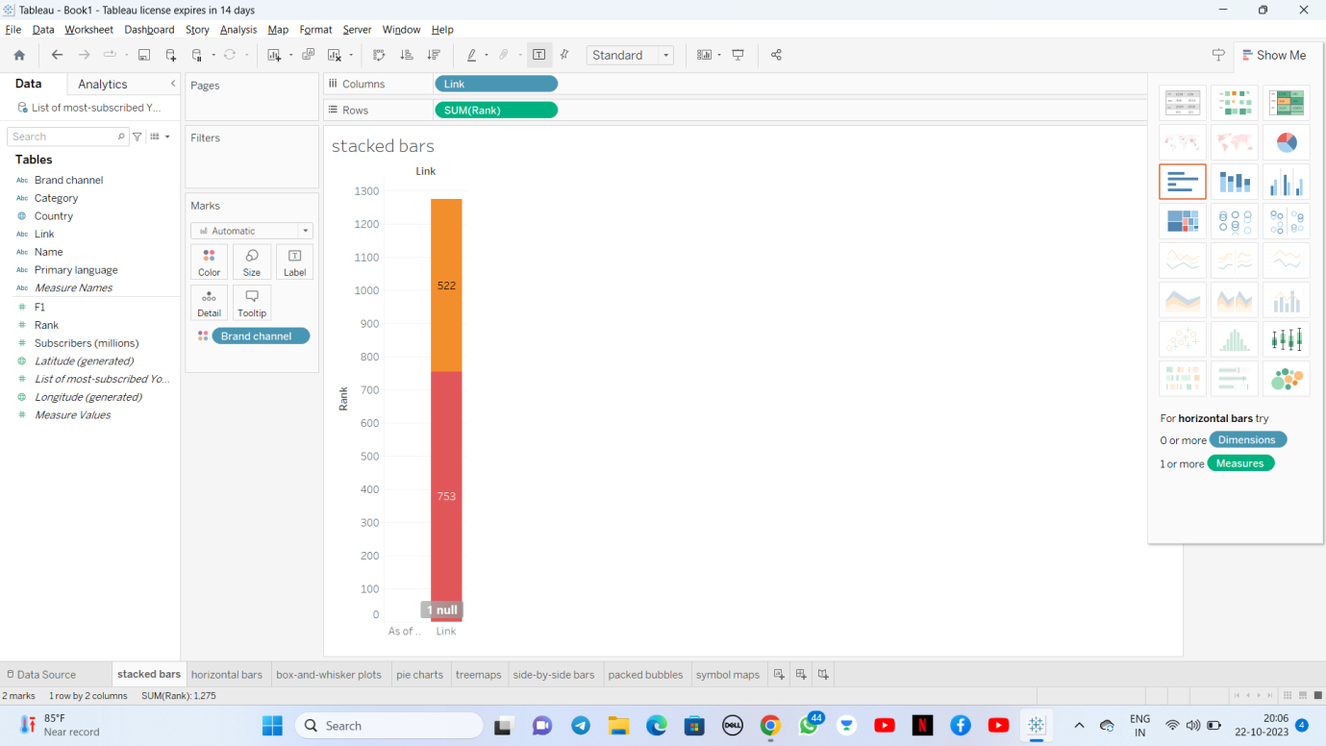

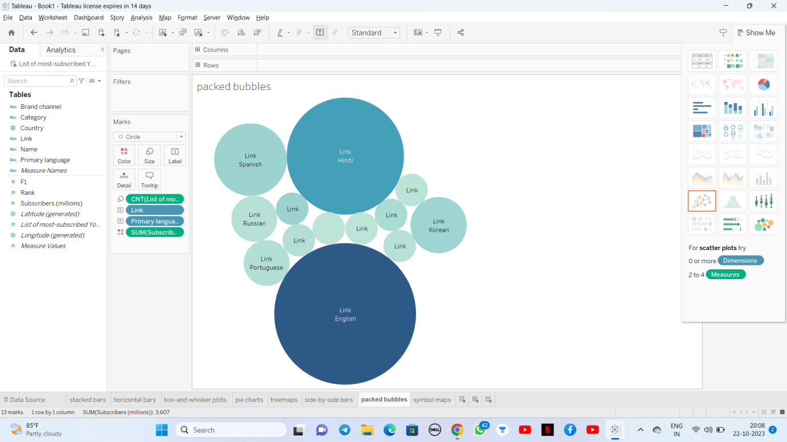

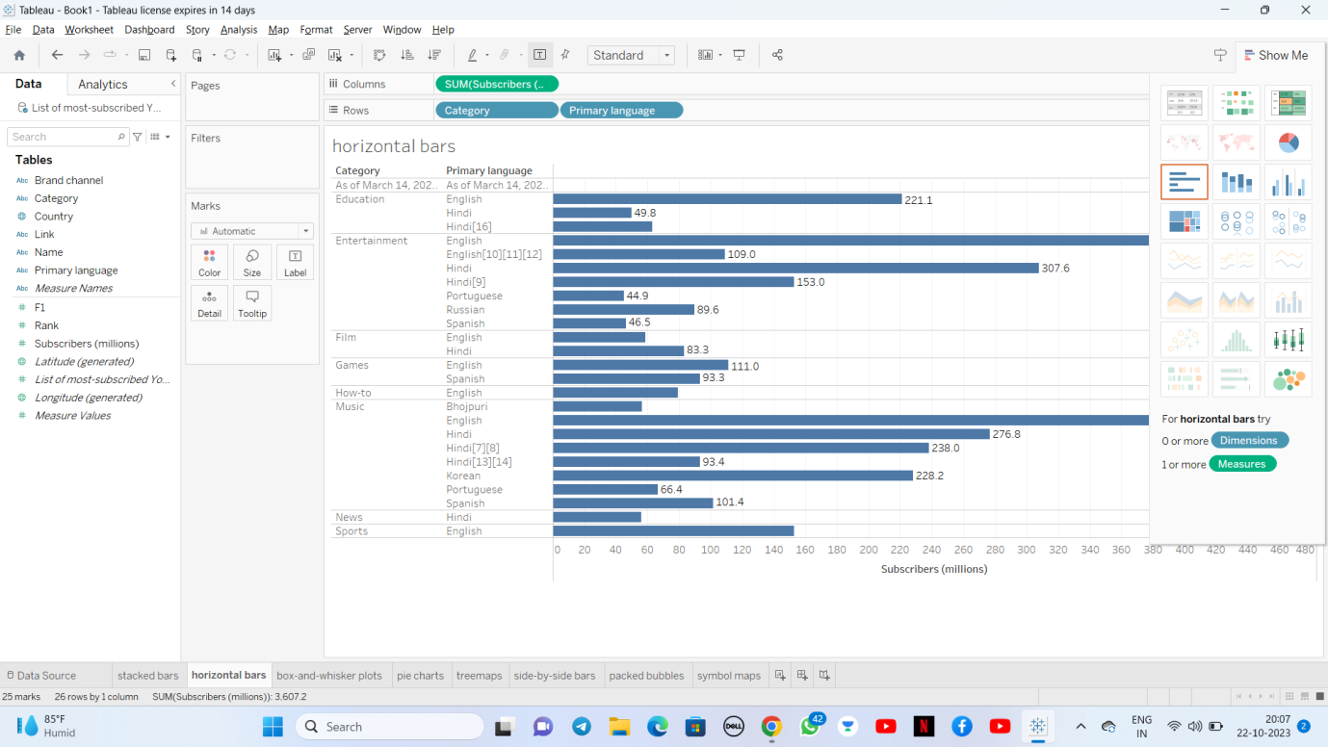

**II) Screenshots of Dashboards**

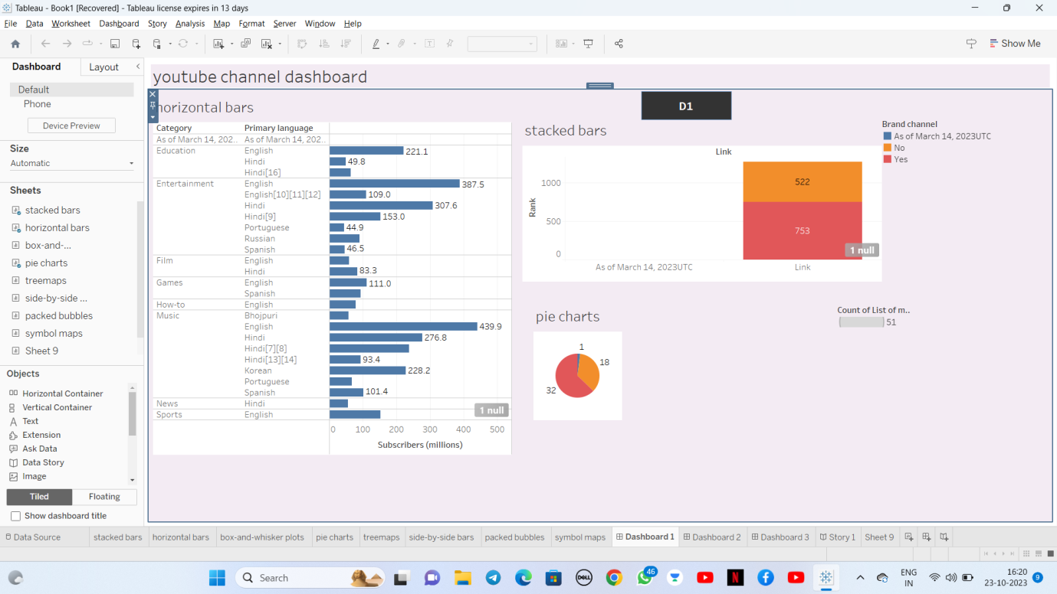

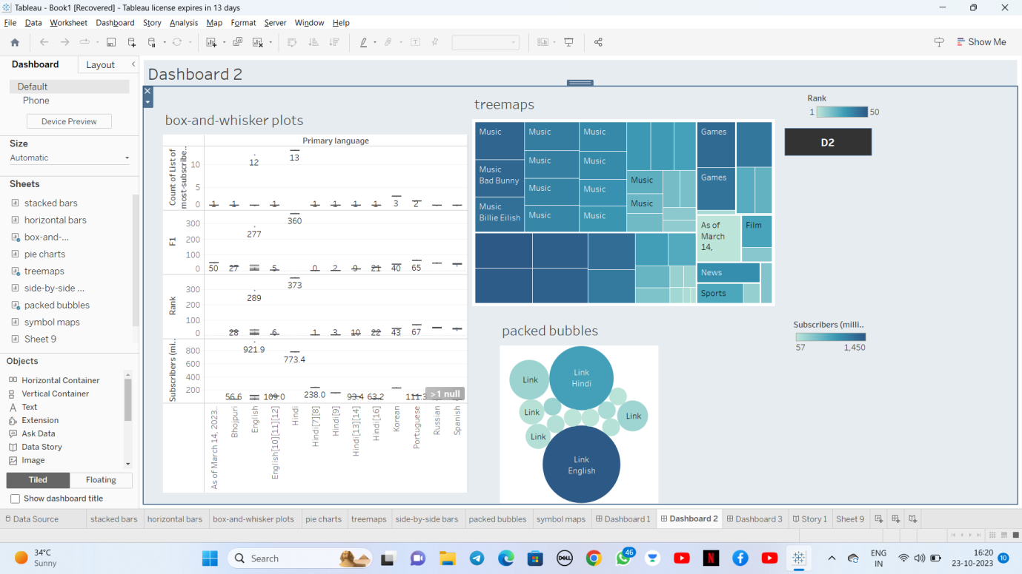

**I )Screenshots of Stories:**

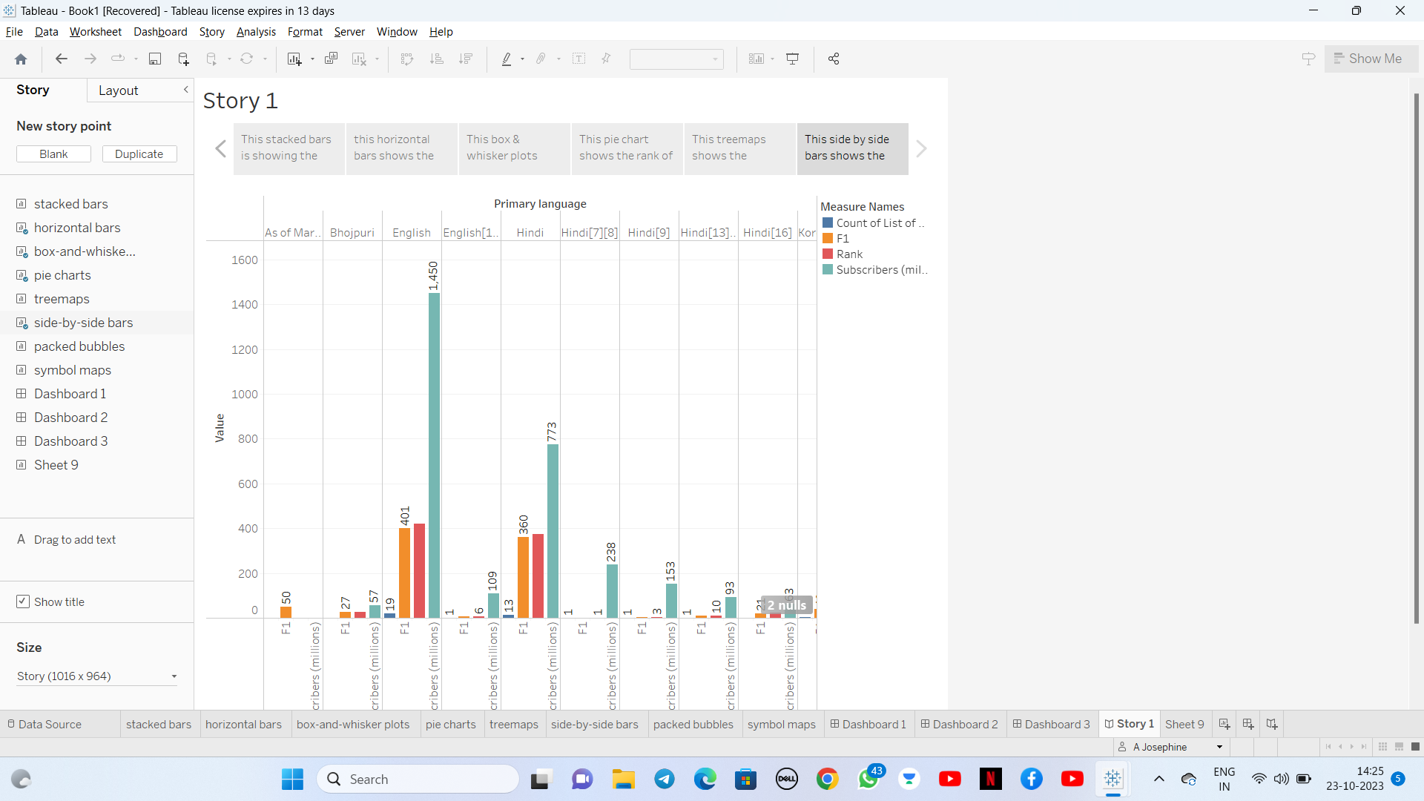

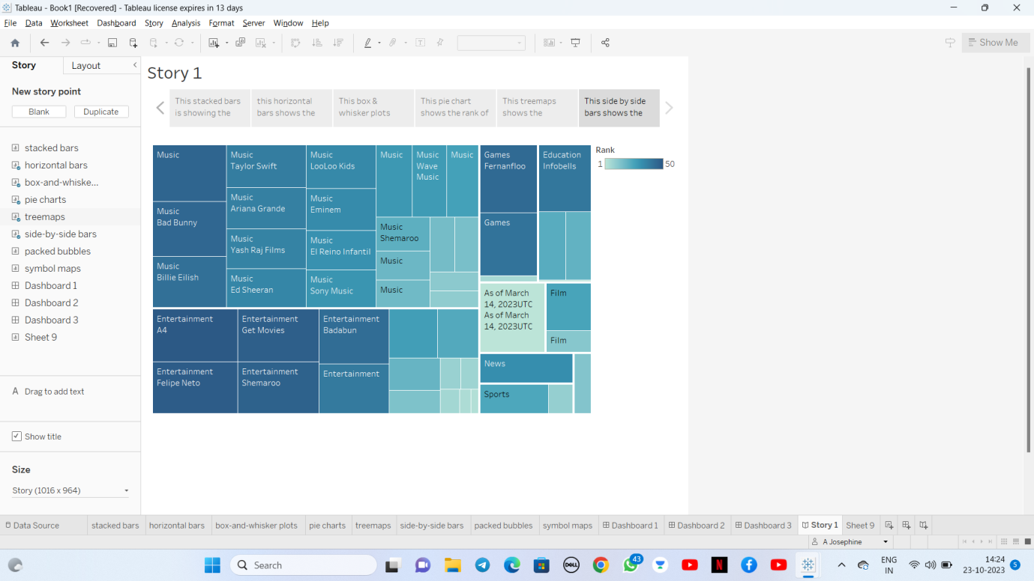

**Screenshots of Published Work**

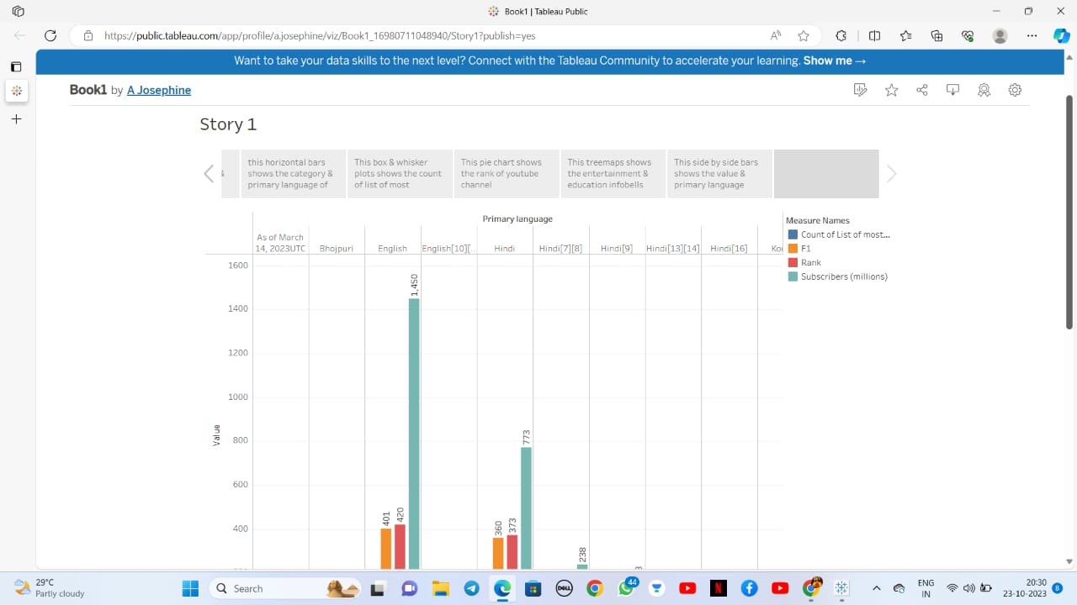

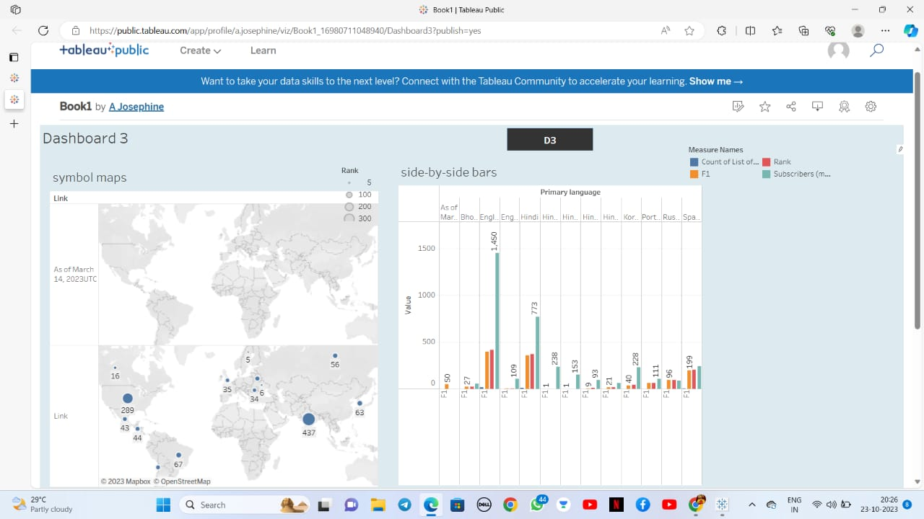

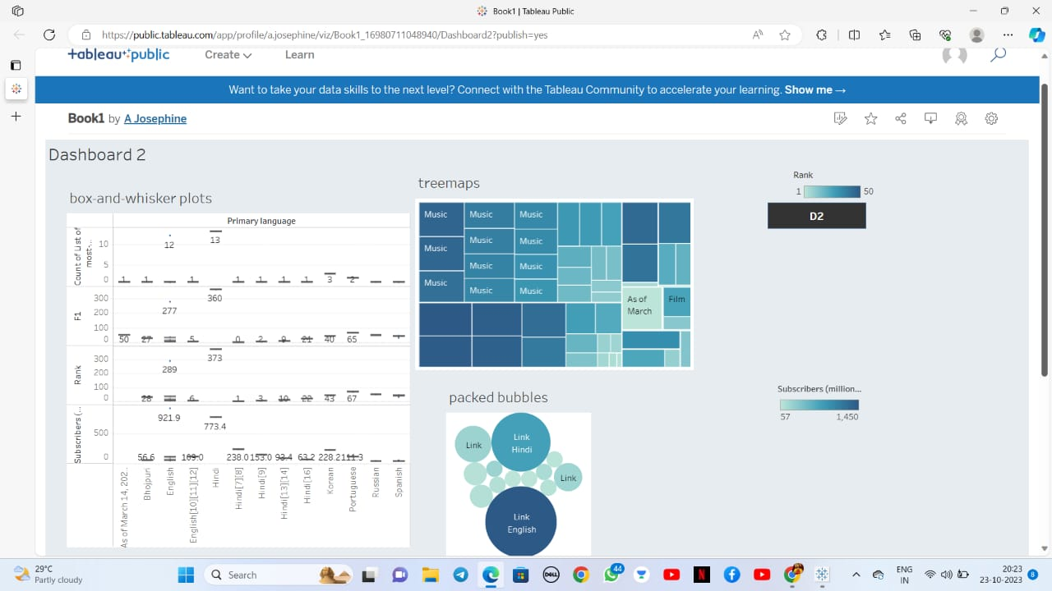

**4. ADVANTAGES & DISADVANTAGES :**

1. Ads- a drawback of you tube for the audience. ADVERTISEMENT….

2. A lot of distraction . ADVERTIAEMENT………..

3. Easy Earning is at the very top of the list of youtube benefits for vloggers**.**

Youtube’s user friendliness .

**5. APPLICATIONS :**

1 Mobile-Friendly

2.Informative Dashboards

3.Advanced Visualization Capabilities

4.Availability of Maps. And so on.

**6. CONCLUSION :**

You tube has an important part in education, because it allows students to learn more about a particular topic or subject just by watching a shorts video . You tube is full of different types of videos that can easily be incorporated and used in classrooms that will give students a better insight on a particular subject. Many online classes today are using you tube as a source for students to learn.